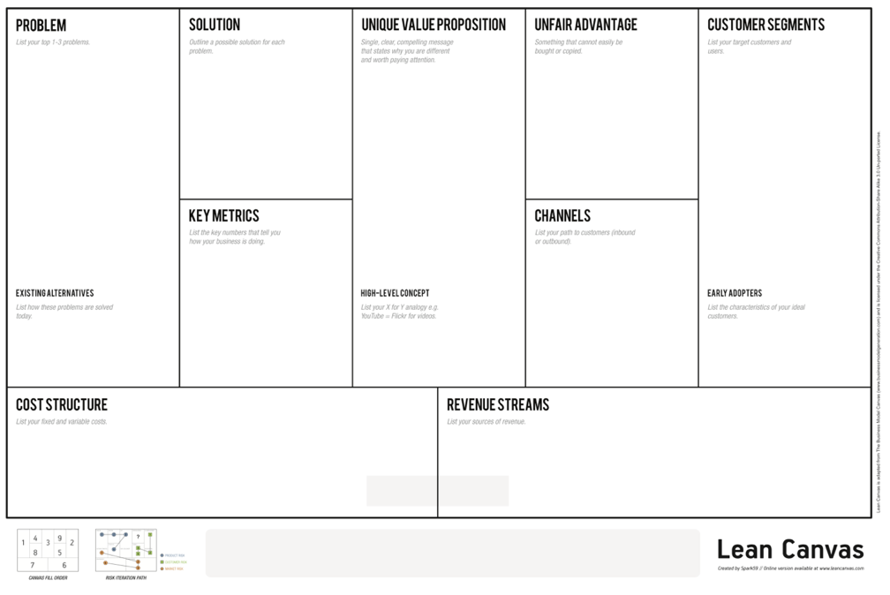
Canvas Version
Company Name

Case Analysis

1) Strategy with Lean Canvas 2) Key Risks 3) Experiment

Is this a good idea? Why or why not?

What are the key risks? Devise an experiment to address that risk
Key Risk | Experiment

If you were the founder, what would be your immediate next steps?

