LEAN CANVAS BUSINESS MODEL
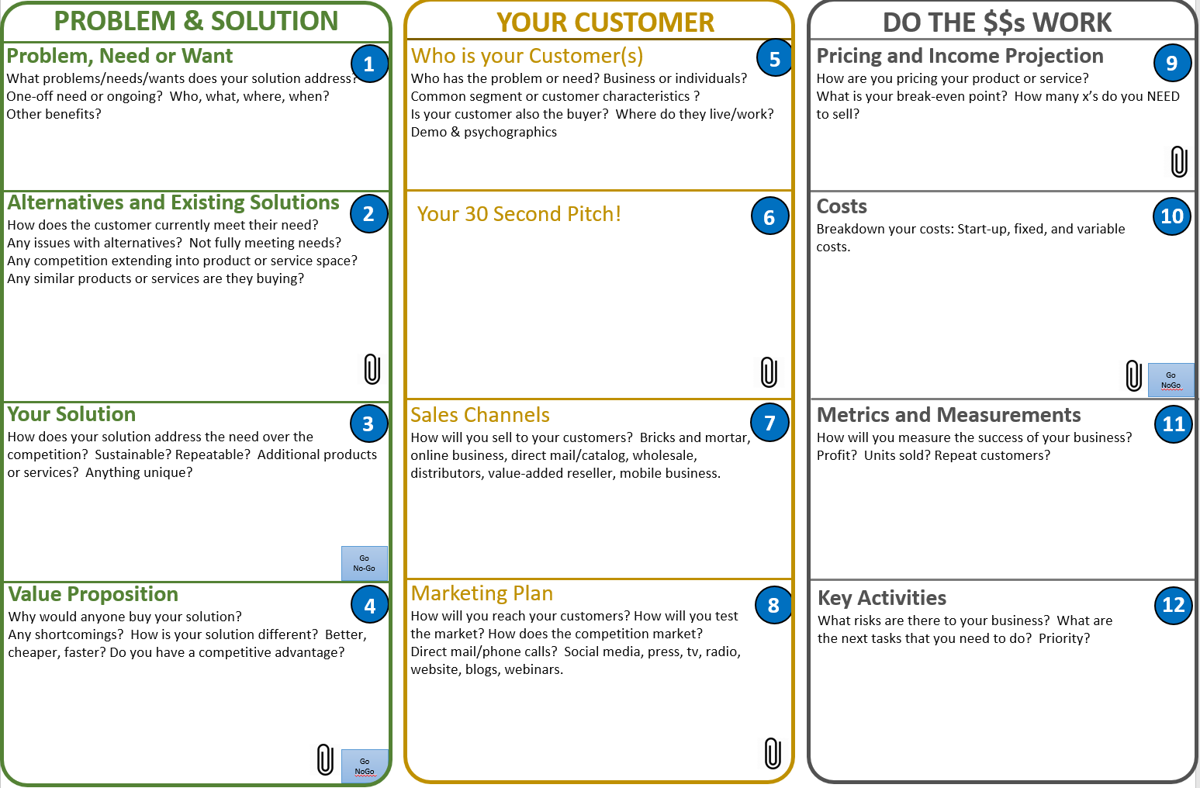

LEAN CANVAS BUSINESS MODEL TEMPLATE
PROBLEMS & SOLUTIONS | YOUR CUSTOMER | DO THE $$ WORK
Problem, Need, Want | Who is your customer? | Pricing & income & projection
Alternative & Existing Solutions | Your 30 second Pitch | Costs
PROBLEMS & SOLUTIONS | YOUR CUSTOMER | DO THE $$s WORK
Your Solution | Sales Channels | Metrics & Measurements
Value Proposition | Marketing Plan | Key Activities

