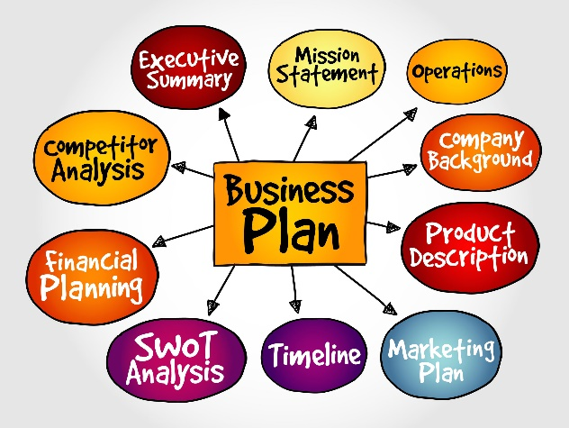
A Simple Business Plan

[Adapted from “Simple Business Plan”, Susan Ward, The Balance SMB]
https://www.thebalancesmb.com/entrepreneur-simple-business-plan-template-4126711

Title Page
Enter your business information including the legal name, address, etc. If you already have a business logo you can add it at the top or bottom of the title page.
- Business Plan for "Business Name"
  - Date
  - Business address
  - Phone
  - Email
  - Website
  - If addressing to a company or individual include: Presented to: "Name"
  - Company or Financial Institution

Table of Contents
- Executive Summary........................................... Page #
- Business/Industry Overview.............................. Page #
- Market Analysis and Competition..................... Page #
- Sales and Marketing Plan.................................. Page #
- Ownership and Management Plan.................... Page #
- Operating Plan................................................... Page #
- Financial Plan..................................................... Page #
- Appendices and Exhibits.................................... Page #

Section 1: Executive Summary
The executive summary goes near the beginning of the plan but is written last. It provides a short, concise, and optimistic overview of your business that captures the reader's attention and creates a need to learn more. The executive summary should be no more than two pages long, with brief summaries of other sections of the plan.
- Describe your mission - what is the need for your new business?
- Introduce your company and the management and ownership.
- Describe your main product and service offerings.
- Briefly describe the customer base you will be targeting and how your business will serve those customers.
- Summarize the competition and how you will get market share (i.e., what is your competitive advantage?)
- Briefly outline your financial projections for the first few years of operation.
- Describe your start-up financing requirements (if applicable).
- An overview of the industry and how your business will compete in the sector. If you need guidance, a Business Plan Example of the Industry Overview will prove useful.

Section 2: Business/Industry Overview
- Describe the overall nature of the industry, including sales and other statistics. Include trends and demographics, and economic, cultural, and governmental influences.
- Describe your business and how it fits into the industry.
- Describe the existing competition.
- Describe what area(s) of the market you will target and what unique, improved or lower cost services you will offer.

Section 3: Market Analysis and Competition
In this section, you need to demonstrate that you have thoroughly analyzed the target market and that there is enough demand for your product or service to make your business viable. The competitive analysis includes an assessment of your competition and how your business will compete in the sector. You can turn to How to Write the Competitor Analysis Section of the Business Plan for help. The target market description and competitive analysis portions can be two separate sections in the plan or combined as shown:
- Define the target market(s) for your product or service in your geographic locale.
- Describe the need for your products or services.
- Estimate the overall size of the market and the units of your product or service the target market might buy, potential repeat purchase volume, and how the market might be affected by economic or demographic changes.
- Estimate the volume and value of your sales in comparison with any existing competitors. It helps to summarize the results in table form as in the following example which demonstrates that there is a gap in the high-quality sector of the market that your business intends to target.
Business | Competitor A | Competitor B | Your Business
Est. Annual Revenue | $1,000,000 | $600,000 | $500,000
Employees | 20 | 10 | 5
Price | Average | High | High
Quality | Low | Average | High

- Describe any helpful barriers to entry that may protect your business from competition, such as access to capital, technology, regulations, employee skill sets, location, etc.

Section 4: Sales and Marketing Plan
A description of how you intend to entice customers to buy your product(s) or service(s), including advertising/promotion, pricing strategy, sales and distribution, and post-sales support if applicable.
Product or Service Offerings
- Describe your product or service, how it benefits the customer, and what sets it apart from competitor offerings (i.e., what is your Unique Selling Proposition?).
Pricing Strategy
- Describe how you intend to price your product or service. Pricing must be competitive to attract customers but high enough to cover costs and generate a profit. Pricing can be based on markup from cost, value to the buyer, or in comparison with similar products/services in the marketplace. Breakeven analysis can help determine sales and pricing for profitability. You'll also want to take a look at Retail Pricing Strategies to Increase Profitability.
Sales and Distribution
- Describe how you will distribute your products to the customer (if applicable). Will you be selling wholesale or retail? What type of packaging will be required? How will the product(s) be shipped? What methods will be used for payment?
Advertising and Promotion
- List the different media you will use to get your message to customers (e.g., business website, email, social media, traditional media like newspapers, etc.). Will you use sales promotional methods such as free samples, product demonstrations, etc.?
- What marketing materials you'll use such as business cards, flyers, brochures, etc. What about product launches and tradeshows? Include an approximate budget for advertising and promotion.

Section 5: Ownership and Management Plan
This section describes the legal structure, ownership, and (if applicable) the management, and staffing requirements of your business.
Ownership Structure
- Describe the legal structure of your company (e.g., corporation, partnership, Limited Liability Company, or sole proprietorship). List ownership percentages if applicable. If the business is a sole proprietorship this is the only section required.
Management Team
- Describe managers and their roles, key employee positions, and how each will be compensated. Include brief resumés.
External Resources and Services
- List any external professional resources required, such as accountants, lawyers, consultants, etc.
Human Resources
- List the type and number of employees or contractors you will need and an estimate of the salary and benefit costs of each.
Advisory Board (if required)
- Include an advisory board as a supplemental management resource (if applicable).

Section 6: Operating Plan
The operating plan outlines the physical requirements of your business, such as office, warehouse, retail space, equipment, inventory and supplies, labor, etc. For a one-person, home-based consulting business the operating plan will be short and simple, but for a business such as a restaurant or a manufacturer that requires custom facilities, supply chains, specialized equipment, and multiple employees, the operating plan needs to be very detailed.
Development (if applicable)
- Explain what you have done to date in terms of identifying possible locations, sources of equipment, supply chains, etc. Describe your production workflow.
Production
- For manufacturing, explain how long it takes to produce a unit and when you'll be able to start producing your product or service. Include factors that may affect the time frame of production and how you'll deal with potential problems such as rush orders.
Facilities
- Describe the physical location of the business including location, land, and building requirements. Include square footage estimates with room for expansion if expected. Include the mortgage or leasing costs. Also include estimates of expected maintenance, utilities, and related overhead costs. Include zoning approvals and other permissions necessary to operate your business.
Staffing
- Outline expected staffing needs and the main duties of staff members, especially the key employees. Describe how the employees will be sourced and the employment relationship (i.e., contract, full-time, part-time, etc.). Detail any employee training needed and how it will be provided.
Equipment
- Include a list of any specialized equipment needed. Include the cost and whether it will be leased or purchased and the sources.
Supplies
- If your business is manufacturing, retail, food services, etc. include a description of the materials needed and how you will reliably source them. Give descriptions of major suppliers if needed. Describe how you will manage inventory.

Section 7: Financial Plan
The financial plan section is the most important section of the business plan, especially if you need debt financing or want to attract investors. The financial plan has to demonstrate that your business will grow and be profitable. To do this, you will need to create projected income statements, cash flow statements, and balance sheets. For a new business, these are forecasts. A good rule of thumb is to underestimate revenues and overestimate expenses.
Income Statements
- The income statement shows your projected revenues, expenses and profit. Do this on a monthly basis for at least the first year for a startup business.
Cash Flow Projections
- The cash flow projection shows your monthly anticipated cash revenues and disbursements for expenses. It is important for demonstrating that you can manage your cash flow and will be a good credit risk.
Balance Sheet
- The balance sheet is a snapshot summary of the assets, liabilities, and equity of your business at a particular point in time. For a startup, this would be on the day the business opens. Note that a new business will have no accounts receivable entries on the balance sheet. Note also that the Balance Sheet is much simpler for unincorporated businesses without employees. Income tax, pensions, medical, etc. are only applicable to incorporated businesses, as are earnings/retained earnings.
Breakeven Analysis
- Including a breakeven analysis will demonstrate to financiers or investors what level of sales you need to achieve to make a profit.
Section 8: Appendices and Exhibits
The appendices and exhibits section contains any detailed information needed to support other sections of the plan.

Possible Appendix/Exhibit Items
- Credit histories for the business owners
- Detailed market research and analysis of competitors
- Resumés of the owners and key employees
- Information about your industry
- Information about your products/services
- Site/building/office plans
- Copies of mortgage documents, equipment leases, etc. (or quotes on these)
- Marketing brochures and other materials
- References from business colleagues
- Links to your business website
- Any other supporting material that may impress potential lenders or investors if you are looking for financing​
- Share
- Tweet
- Share
- Email

