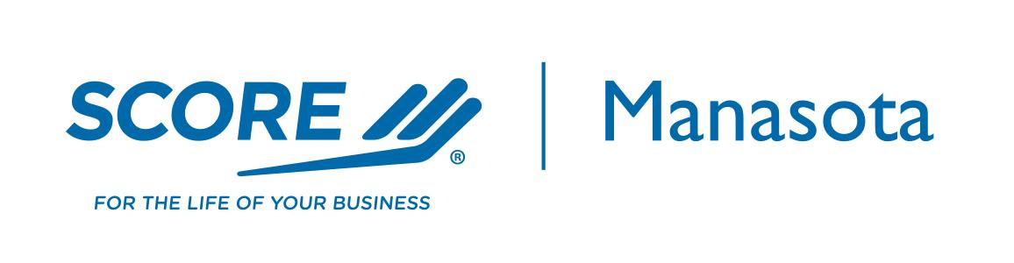
Elevator Pitch – Explain Your Business

My Company ____________________________________________________ (Name)

Offers __________________________________________________________ (Your Offer)

Helping _________________________________________________________ (Target Audience)

Value Proposition ________________________________________________ (The Problem You Solve)

By _____________________________________________________________ (How You Do This)

Example:
BankUnited offers business funding and deposit services helping business owners solve their cash flow problems by listening, learning and providing custom solutions.

Guidance: Explain your business to potential customers and stakeholders.
Grab the listener's attention by explaining your business (idea) clearly and concisely in one sentence.
- Your offer must be short and easily understood.
- The audience is your target group most likely to be interested in what you offer.
- The problem you solve must resonate with this audience.
- How you do this provides your unique approach to solving their problem.

Elevator Pitch is Sponsored by

